Lab05: Joining Tables and set operators

Objectives:
To learn the use of Joins in SELECT statement.
To combine the results of multiple queries into a single result set

Joins

By using joins, you can retrieve data from two or more tables based on logical relationships between the tables. Joins indicate how SQL should use data from one table to select the rows in another table.

A join condition defines the way two tables are related in a query by:

- Specifying the column from each table to be used for the join. A typical join condition specifies a foreign key from one table and its associated key in the other table.
- Specifying a logical operator (for example, = or <>,) to be used in comparing values from the columns.

There are various forms of the JOIN clause. These will include:
- INNER JOIN
- OUTER JOIN (both LEFT and RIGHT)
- FULL OUTER JOIN
- CROSS JOIN
- SELF JOIN (A self-join is a query in which a table is joined (compared) to itself.)
A JOIN does just what it sounds like—it puts the information from two tables together into one result set. We can think of a result set as being a “virtual” table. It has both columns and rows, and the columns have data types. How exactly does a JOIN put the information from two tables into a single result set? Well, that depends on how you tell it to put the data together—that’s why there are four different kinds of JOINs. The thing that all JOINs have in common is that they match one record up with one or more other records to make a record that is a superset created by the combined columns of both records.

- INNER JOINs
INNER JOINs are by far the most common kind of JOIN. This join will return all of the records in the left table (table A) that have a matching record in the right table (table B).
In simple words, this join returns records that have matching values in both tables.
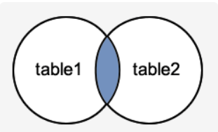
Syntax:
SELECT columns
FROM table1
INNER JOIN table2 ON table1.column = table2.column;

- LEFT OUTER JOIN
Return all of the records in the left table (table A) regardless if any of those records have a match in the right table (table B). It will also return any matching records from the right table. If there's no match, NULL values are returned for the columns from the right table.
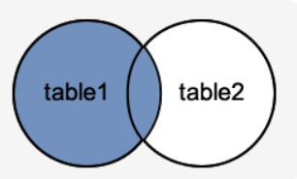
SYNTAX
SELECT columns
FROM table1
LEFT JOIN table2
ON table1.column = table2.column;

- RIGHT OUTER JOIN
Returns all records from the right table (tableB), and the matched records from the left table (tableA). If there's no match, NULL values are returned for the columns from the left table.
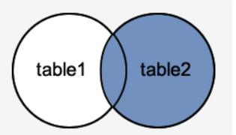
SYNTAX
SELECT columns
FROM table1
RIGHT JOIN table2
ON table1.column = table2.column;

- FULL OUTER JOIN
Return all of the records from both tables, joining records from the left table (table A) that match records from the right table (table B).
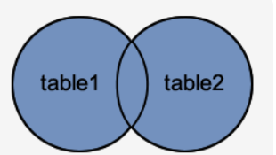

SYNTAX
SELECT columns
FROM table1
FULL JOIN table2
ON table1.column = table2.column;

- CROSS JOIN
Returns the Cartesian product of the two tables, i.e., all possible combinations of rows.
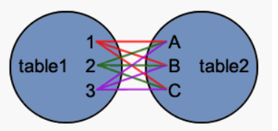
SYNTAX
SELECT columns
FROM table1
CROSS JOIN table2;

- SELF JOIN
A self-join is a regular join, but the table is joined with itself. It is a query in which a table is compared to itself.
Self-joins are used to compare values in a column with other values in the same column in the same table.

SYNTAX
SELECT columns
FROM table1
WHERE condition;

EXAMPLE:

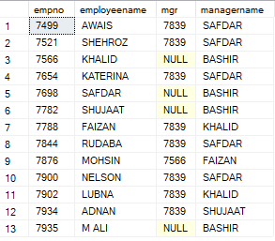

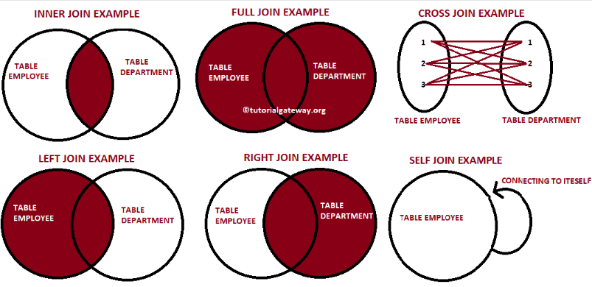

Set operators

Set operators in SQL allow you to combine the results of multiple queries into a single result set. There are three main set operators: UNION, INTERSECT, and EXCEPT

The UNION operator is used to combine the result-set of two or more SELECT statements.

- Every SELECT statement within UNION must have the same number of columns
- The columns must also have similar data types
- The columns in every SELECT statement must also be in the same order

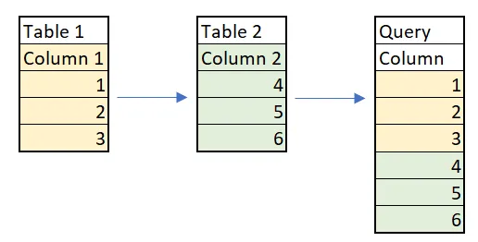

The INTERSECT operator is used to retrieve the records that are identical/common between the result sets of two or more tables. To put it simply, it acts as a mathematical intersection. In mathematics, the intersection of A and B is the common data present in both A and B.

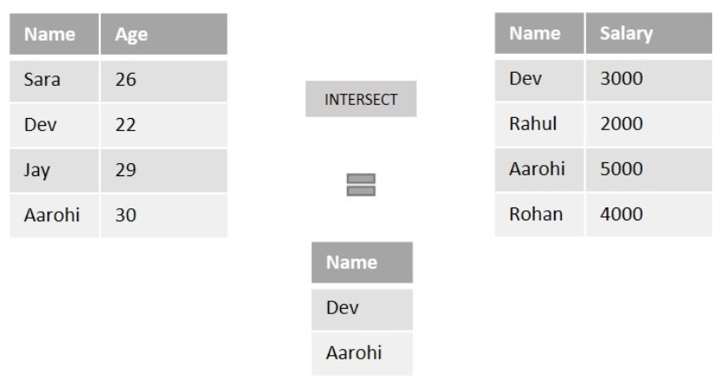

The EXCEPT operator compares the distinct values of the left query with the result set of the right query. If a value from the left query is found in the result set of the right query, it is excluded from the final result.

